**1. Basic Info**

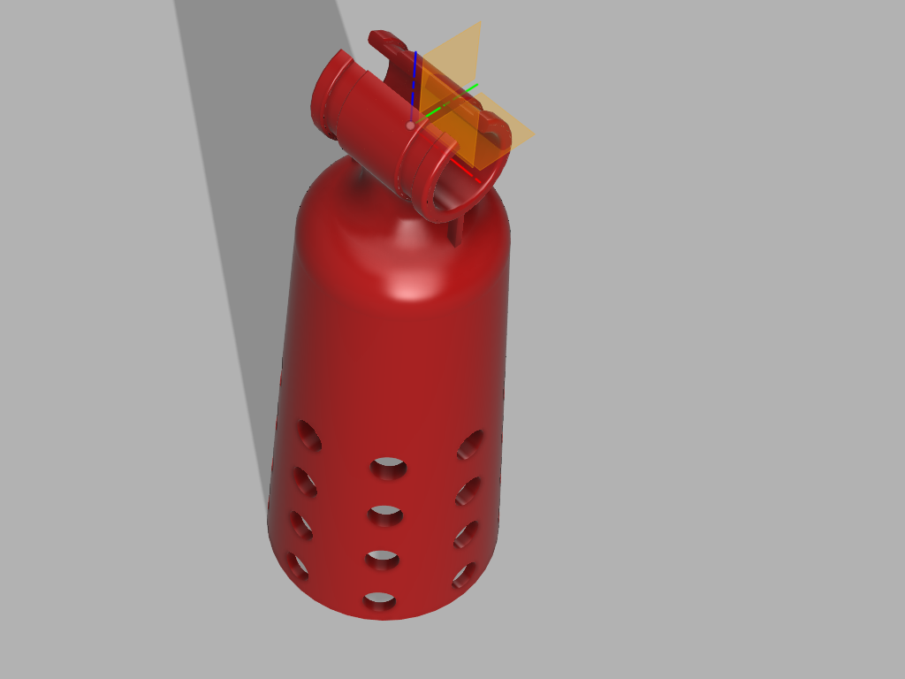

**Author:** Michele Praga and Alessandro Villa

**Device type:** Arm

**Minimum user needs:** A functioning forearm

**Type of device:** Mechanical

|  |  |  |  |  |
| --- | --- | --- | --- | --- |
| **Maturity** | **Cost of Materials** | **Popularity** | **Assembly difficulty** | **Grip Strength** |
|  |  |  |  | N/A |

To learn about what each of the above icons represents, please refer to the [Device Ratings Guide](https://hub.e-nable.org/s/chapter-spotlight/wiki/page/view?title=Project+Ideas+%26+Suggestions#null).

**Development status:** In validation

**Basic data**

* Number of parts: 1
* Assembly time (estimated): 0.5 hrs
* Store-bought parts: zip cable ties
* Number of known builds: 3
* Grip type: none
* Actuation type: no actuation
* Scalability: STL or 3MF is generated by Autodesk Fusion360 using parameters

**Basic description**

This device is intended to be connected to the bike handlebar through zip ties. The elasticity of the joint ensures a adequate mobility for steering.

**License:** Creative Commons Attribution-NonCommercial-ShareAlike 4.0 International (CC BY-NC-SA 4.0)

**Credit and Contributions:** missing credit

**2. Links**

**Main STL Files:** <https://www.thingiverse.com/thing:xxxxxxx>

**Major Modifications:** 🔴

You can request a modification in the comments below

**Source Files:** Fusion360 file in download area

**Instructionals:**

An instructional document is available with in download area

**Editors and Customizers:** N/A

**3. Makers**

missing photo of made device 🔴

**Bill of Materials**

* Cable zip ties
* TPU filament

**Tools:** cut plier

**Recommended print settings:**

Rafts:  
No

Supports:  
No

Resolution:  
0.2

Infill:  
60%

Filament brand:

Ninjaflex

Filament color:

N/A

Filament material:

TPU, suggested shore 85a, higher shore gives more rigidity, use lower for additional flexibility for the device.

**Device advantages:** Simplicity

# 4. Educational

After several design iterations, the team e-Nable Italia released the first prototypes of what is simply called “Bike Adapter”.

The device is designed in Autodesk Fusion360 that is free for hobbyists, non-commercial use, and for qualifying startups.

In the parameter window, the user inputs some dimensions of unaffected and affected arm, and the software automatically generate the 3D model.

The Bike Adapter design is being released under a Creative Commons Attribution-Non Commercial-ShareAlike 4.0 International (CC BY-NC-SA 4.0) open-source license to encourage further innovation in this field, and improve global access to assistive technology.

This design is released for trial and evaluation purposes only, and it is intended to benefit certain individuals with specific arm differences and is not intended, and shall not be used, for commercial purposes.

The acceptance of this design by e-Nable Italia, and any such information provided by the design team is presented as is without representation or warranties of any kind, express or implied, and is intended to be a free gift to recipients for the sole purpose of evaluating various design iterations, ideas and modifications. The Bike Adapter must be used for only light biking activities, and not for any severe tasks like off-road or competitive events. Any individual associated with e-Nable Italia and e-Nable Italia itself shall not be liable for any injuries or damages resulting from the use of any information or designs provided. The Bike Adapter is experimental device, it is not classified as a medical device, and it is for evaluation purposes only. In some cases, these devices will not be appropriate for each individual, and consultation with medical professionals and occupational therapists must be sought and obtained before use.

The Bike Adapter has been designed using Autodesk Fusion 360.

No historical credits available.

**Further Information**

Check for further information, updates and information on this and other e-Nable Italia’s projects on our website: <https://e-nableitalia.it/bikeadapter> & <https://e-nableitalia.it>

# 5. Engineering (sizing)

Only four parameters are needed to properly size the device.

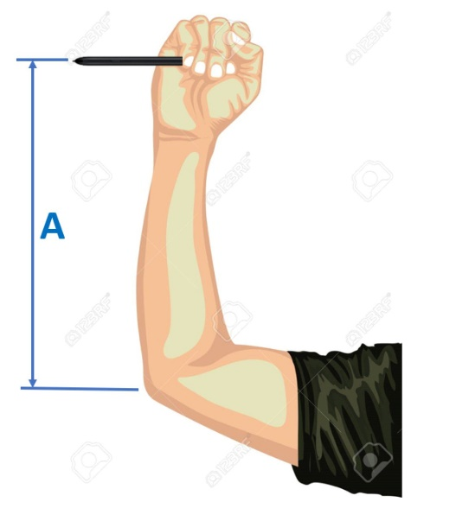

Figure 1 - measure of unaffected arm

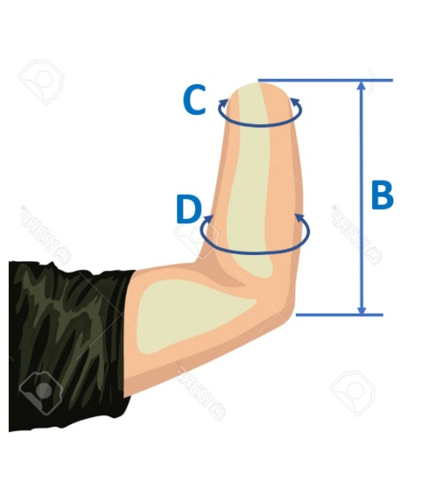

Figure 2 - measure of affected arm

A – unaffected forearm length

B – affected forearm length

C – tip stump diameter

D – root stump diameter

An additional parameter, the number of venting holes, could be modified according to the length of the stump wall.

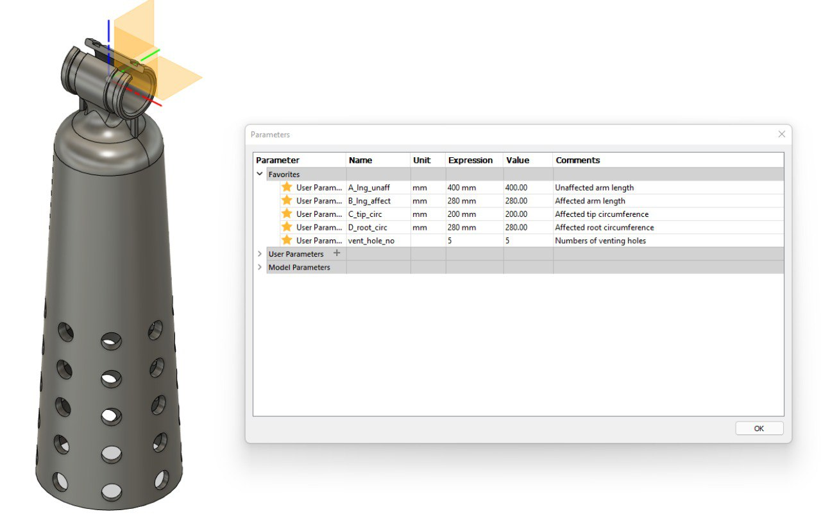

Figure 3 - Parameter window

The file is designed in a way in which the walls thickness is inversely proportional to the length of the affected arm, in order to provide necessary lateral stability.

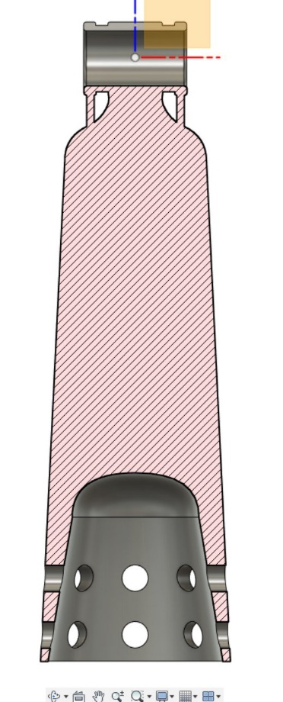

Figure - Short stump configuration

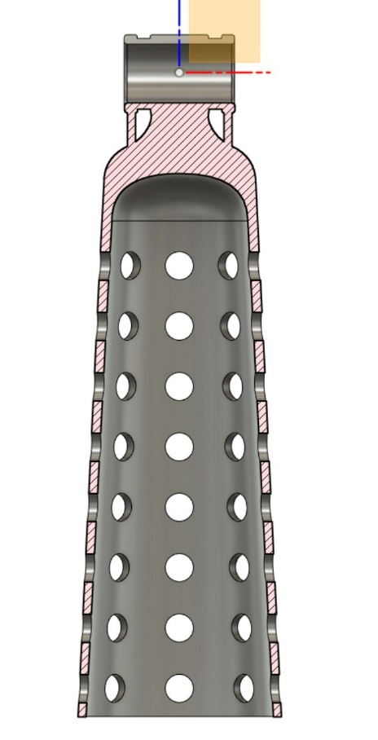

Figure 5 - Long stump configuration

The grip on the bike handlebar is ensured by the frictions between TPU and rubber handles. The handle grip pillow has two slots to keep in position two cable zip ties.

N/A

**Known issues and solutions**

no issues have been reported

Do you know of an issue with this device? Do you have a solution for a common issue? 🔴

**Help resources**

If you aren’t familiar with Fusion 360, you can contact e-Nable Italia team. Providing the four mentioned dimensions, e-Nable Italia can generate the STL or 3MF file for you.

**Requested Modifications**

no modifications have been requested at this point

# 6. Lists & Media

**Media links:** no links available 🔴



